Docker Compose
- This is a tool for defining a running multi container Docker application
- All the modern applications will have the some/all of the following components 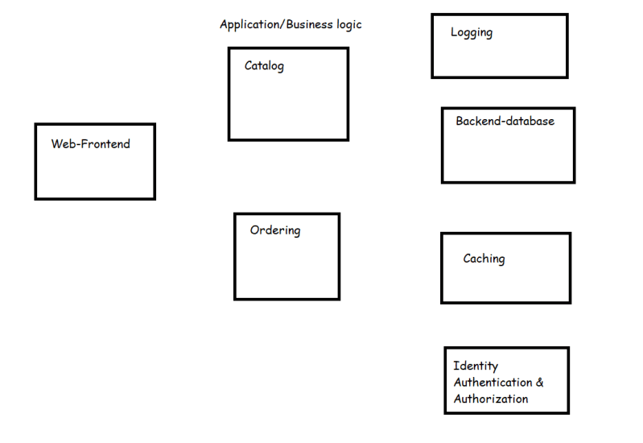
- When all of these components work together, we have a successful application
- Let’s understand microservices
- To bring up our application we need to run multiple containers in a specific order.
- Docker compose is one approach to bring up multiple containers of your application on a single docker host platform.
- Docker compose is widely used in Developer environments
- Docker stack is one more approach which helps to run multiple containers of your application on multi nodes.

Microservices
- This is an architectural pattern that structures and application as a collection of services that are
  - Highly maintable and testable
  - Loosely coupled
  - Independently deployable
  - Organized around business capabilities
- Simple microservice architecture 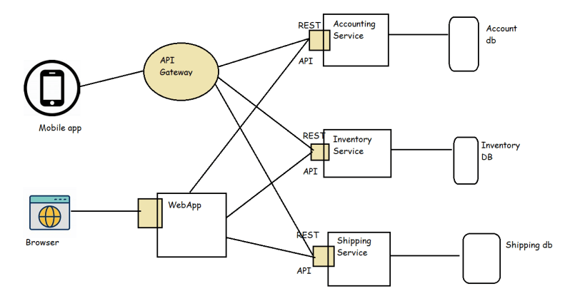
- Now we can deploy each service in a container/vm Now this gives us the following benifits
  - We can have parallel developments for each service
  - Reusability of services can be done across applications
  - We can scale the individual services when there is load.
- The best way to run individual services is in containers and to manage the whole application deploymets we use orchestration platforms such as
  - Kubernetes
  - Docker Swarm
  - OpenShift
Docker compose: Compose is a tool for defining and running multi-container Docker applications. With Compose, you use a YAML file to configure your application's services. Then, with a single command, you create and start all the services from your configuration.

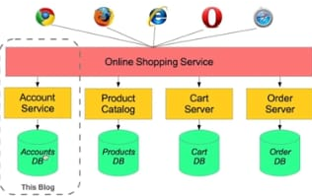

Install Compose on Linux systems
On Linux, you can download the Docker Compose binary from the Compose repository release page on GitHub. Follow the instructions from the link, which involve running the curl command in your terminal to download the binaries. These step-by-step instructions are also included below.
For alpine, the following dependency packages are needed: py-pip, python3-dev, libffi-dev, openssl-dev, gcc, libc-dev, rust, cargo and make.
Step1: Run this command to download the current stable release of Docker Compose:
sudo curl -L "https://github.com/docker/compose/releases/download/1.28.5/docker-compose-$(uname -s)-$(uname -m)" -o /usr/local/bin/docker-compose
Note:To install a different version of Compose, substitute 1.28.5 with the version of Compose you want to use.
If you have problems installing with curl, see Alternative Install Options tab above.Apply executable permissions to the binary:
sudo chmod +x /usr/local/bin/docker-compose
Note: If the command docker-compose fails after installation, check your path. You can also create a symbolic link to /usr/bin or any other directory in your path.
sudo ln -s /usr/local/bin/docker-compose /usr/bin/docker-compose

$ docker-compose --version
docker-compose version 1.28.5, build 1110ad01

be understandable even if you’re not familiar with it.

Prerequisites
Make sure you have already installed both Docker Engine and Docker Compose. You don’t need to install Python or Redis, as both are provided by Docker images.

Step 1: Setup
Define the application dependencies.
Task1 -Create a directory for the project:
mkdir composetest
cd composetest
Create a file called app.py in your project directory and paste this in:
import time
import redis
from flask import Flask

app = Flask(__name__)
cache = redis.Redis(host='redis', port=6379)

def get_hit_count():
retries = 5
while True:
try:
return cache.incr('hits')
except redis.exceptions.ConnectionError as exc:
if retries == 0:
raise exc
retries -= 1
time.sleep(0.5)

@app.route('/')
def hello():
count = get_hit_count()
return 'Hello World! I have been seen {} times.\n'.format(count)

TASK-2: Create another file called requirements.txt in your project directory and paste this in: flask redis

TASK-3: Create a Dockerfile
FROM python:3.7-alpine
WORKDIR /code
ENV FLASK_APP=app.py
ENV FLASK_RUN_HOST=0.0.0.0
RUN apk add --no-cache gcc musl-dev linux-headers
COPY requirements.txt requirements.txt
RUN pip install -r requirements.txt
EXPOSE 5000
COPY . .
CMD ["flask", "run"]
This tells Docker to:
- Build an image starting with the Python 3.7 image.
- Set the working directory to /code.
- Set environment variables used by the flask command.
- Install gcc and other dependencies
- Copy requirements.txt and install the Python dependencies.
- Add metadata to the image to describe that the container is listening on port 5000
- Copy the current directory . in the project to the workdir . in the image.
- Set the default command for the container to flask run.
For more information on how to write Dockerfiles, see the Docker user guide and the Dockerfile reference.

TASK 4: Define services in a Compose file
Create a file called docker-compose.yml in your project directory and paste the following:
version: "3.9"
services:
web:
build: .
ports:
- "5000:5000"
redis:
image: "redis:alpine"

TASK5: Build and run your app with Compose
docker-compose up

Verify by using http:host-name:5000
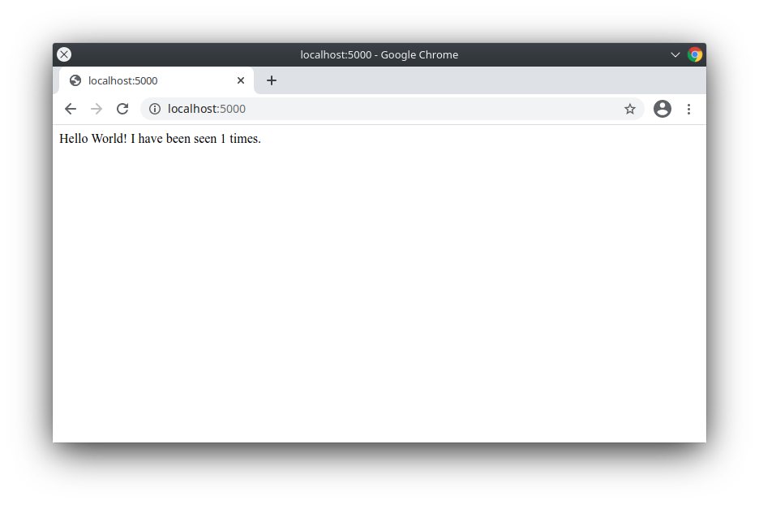Refresh the page. The number should increment.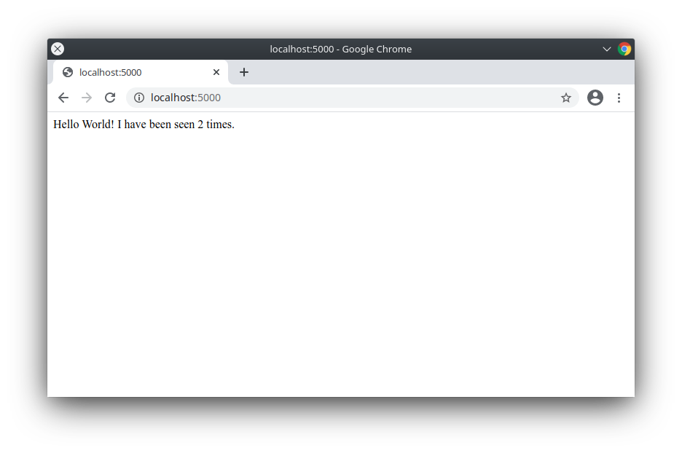
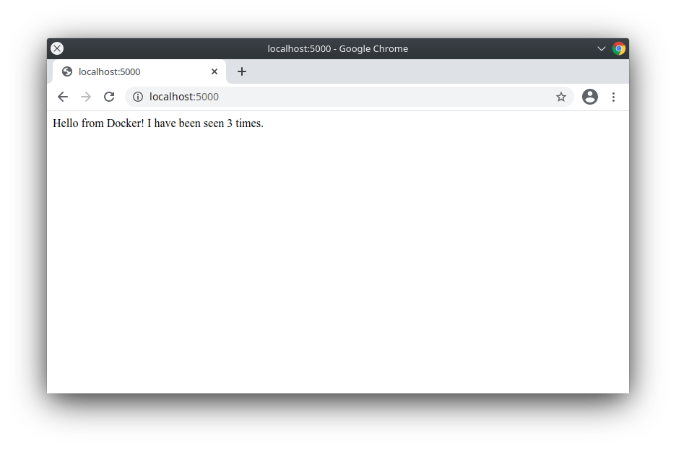

TASK6: Experiment with some other commands
docker-compose up -d
docker-compose ps
docker-compose stop

Run container in Production Environments
- We generally run Production environment on multiple servers
- So if we run our application which is microservices in the production environment, We have to deal with
  - Multiple containers
  - Ensure that the containers are running
  - We need to scale the containers depending on demand
  - We need to persist the volumes
- A distributed systems cluster is a group of machines that are virtually or geographically separted and they work together to provide the same service or applications to clients
- A distributed system can help
  - There is no single point of failure (SPOF)
  - This design supports scalability
  - The data is shared b/w all machines
  - The design is readable
- Consensus is the task of getting all the systems ina group agree on some specific values based on votes. Docker swarm uses raft consensus algorithm Refer Here
- The configuration or state of the system will be stored in the database on all managers. In the case of docker swarm this database is etcd
- We need to manage networks for multiple nodes and we already know about overlay
- Docker Swarm supports loadbalancing to interact with services externally as well as internally
- How can we deploy our application i.e. new microservice version in container with out downtime?
- Docker has a swarm mode which is running docker containers on multiple nodes with cluster features
  - Manager & Worker nodes
  - Multi node networking
  - Load balancing
  - Deployments
  - Scalability
- To be very frank industry has majorly adopted kubernetes as the orchestration technology for running contaniers in production.
- To run multiple applications on docker swarm which is
  - Service => Task
  - Docker has developed a docker stacks or you can use docker command line

Running Docker Containers
- With CPU Limits 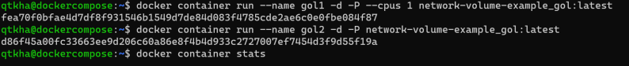
- With memory limits 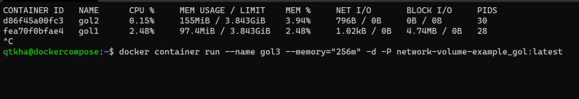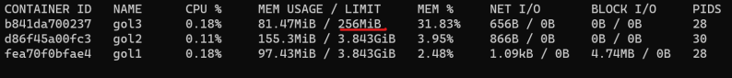
For limiting cpu, ram for docker container (Link: https://docs.docker.com/config/containers/resource_constraints/)
- Docker container allows us to change few configurations while the container is running 